Crazy Curls  Write each spelling in curly writing  cat | Back & Forth  Write each spelling backwards then forwards  said dias | Rainbow Write  Write each spelling, then trace in rainbow colours  jump
Shouting Spellings!  Write each spelling in CAPITAL LETTERS!  YES  POT  AND | Bubble Write  Write each spelling in bubble writing | Picture Perfect  Write each spelling with a mini picture beside  cat  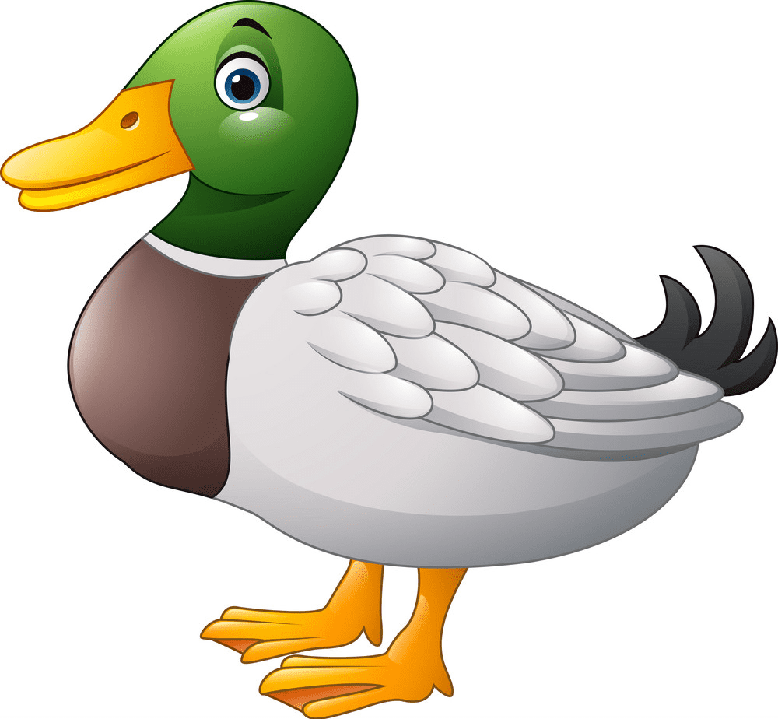  duck  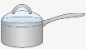  pot
Silly Sentences  Choose 3 spellings to include in 3 silly sentences  I saw a green cat. | Three Times  Write each spelling once in pencil, a 2nd time in coloured pencil and a 3rd in pen  the the the | Hidden Picture  Draw a picture and hide all of your spelling words within your picture
Pyramid Words  Write 4 spellings in a pyramid shape, e.g.  in  and  said  land | Best to Worst  Write your spellings in order from your favourite spelling to your least favourite.  to, in, pot, hot, wet, yes | Shade the Shape  Some letters, like o, p, d, b and q have shapes in them. Shade in any shapes using bright colours!  sand jump  drop
Active Spelling Menu

